Experiment : 5
Date:

CLASS DIAGRAM AND TIME SEQUENCE

Aim:
To design and analyse UML Class Diagram and Time Sequence Diagram in order to understand the structural composition and time-based interaction of components within a software system.

Introduction:
In software engineering, visualization of system design is essential before implementation. Unified Modeling Language (UML) serves as a universal modelling standard that enables developers to represent system architecture and functionality in a graphical format.
UML diagrams simplify complex designs by dividing them into structural and behavioural views. In this experiment, the Class Diagram is used to depict the static framework of the system, while the Time Sequence Diagram illustrates the dynamic communication and execution order among objects. Together, these diagrams provide a comprehensive understanding of system design and operational flow.

Class diagram :
The Class Diagram describes the static blueprint of the system by identifying classes, their internal attributes, operations, and interrelationships. Each class symbolizes an entity that contains data members and member functions defining its structure and behaviour.
Relationships between classes establish connectivity within the system. Association denotes general linkage, inheritance supports hierarchical property sharing, and aggregation represents whole–part associations. These relationships collectively define how system components collaborate structurally.
Designing a class diagram assists developers in organizing system modules effectively. It promotes object-oriented development, enhances reusability, and simplifies system maintenance. Moreover, it acts as a foundational reference during coding and database design.

Components of Class Diagram:
- Classes – Represent system entities or objects.
- Attributes – Define the properties of a class.
- Methods/Operations – Specify functions performed by a class.
- Relationships – Show connections between classes.

By using a class diagram, developers can clearly visualize the architecture of the software and understand how objects are organized within the application.
This diagram helps in planning the system design before implementation and improves maintainability and scalability.

Applications of Class Diagram
- Software architecture planning
- Object-oriented system analysis
- Database schema design
- Requirement representation
- Technical documentation
- Code development guidance
- System maintenance and expansion

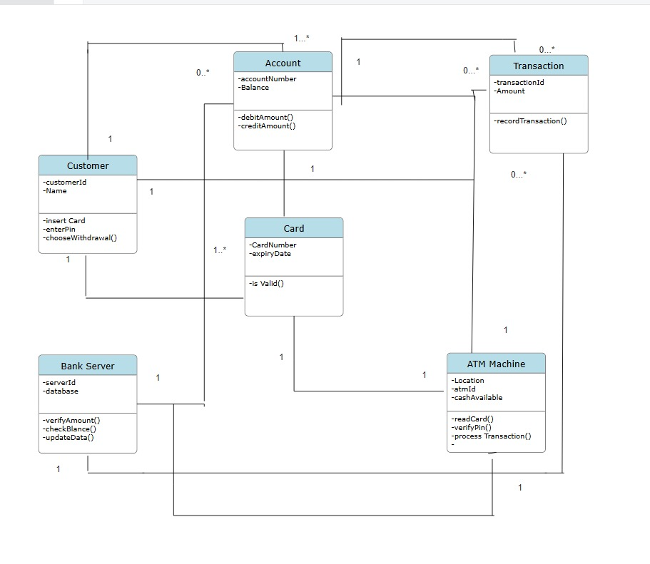

Time sequence diagram :
The Time Sequence Diagram represents the behavioural perspective of the system by illustrating how objects interact sequentially over a period of time. It emphasizes the order of message exchange and the duration of processes involved in execution.
Objects participating in the interaction are represented through lifelines, while communication between them is shown using directional messages. Activation bars highlight processing intervals, enabling clear visualization of operational timing.
This diagram plays a crucial role in analysing workflow progression, synchronization of activities, and system responsiveness. It is particularly useful in modelling real-time applications where timing accuracy is critical.

Purpose of Time Sequence Diagram:
- To visualize interaction flow among objects
- To analyse execution sequence step-by-step
- To track message transmission
- To study runtime system behaviour
- To ensure synchronization of processes

Key Elements:

- Objects / Lifelines – Participating entities.
- Messages – Communication between objects.
- Activation Bars – Duration of processing.
- Time Axis – Shows order of execution.

Applications:
- Banking systems
- Library management systems
- ATM operations
- Online shopping platforms
- Student information systems

Advantages of UML Modelling:

- Simplifies complex designs.
- Improves communication among developers.
- Supports accurate documentation.
- Detects errors at early stages.
- Saves development time and cost.

It focuses on how messages are passed between components and how processes occur step by step during execution.
This diagram is useful for understanding system workflows, detecting logical errors, and ensuring that operations occur in the correct sequence.
It provides a clear view of communication between different parts of the system.
The Time Sequence Diagram plays a vital role in understanding the behavioural perspective of a software system.
It provides a clear visualization of interaction flow, execution timing, and system responses, thereby supporting developers in designing accurate, efficient, and well-coordinated software solutions.

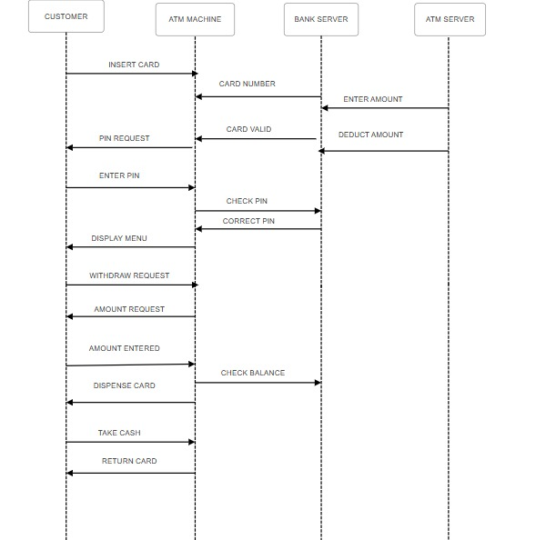

Conclusion:
Thus, the UML Class Diagram and Time Sequence Diagram were successfully constructed and examined. The experiment enabled a clear understanding of both the structural organization and behavioural execution of the system. It enhanced modelling proficiency, design analysis capability, and documentation skills. Overall, this study reinforced the significance of UML techniques in developing structured, efficient, and scalable software solutions.

